HACETTEPE UNIVERSITY
Department of Computer Engineering

Fuzzy Modelling
Laboratory

Furkan Simsekli
5th Semester
Turkey

Academic Year 2023/2024

Exercise 9

Design a fuzzy controller. The controller has two inputs and one output. The range of changes for the input signals are ZX1, ZX2 and for the output signal is ZY.

The changes of the input signals are described using three symmetric triangular membership functions. The changes of the output signal are described using five symmetric Gaussian membership functions.

The modal values of the triangular membership functions are equal: x1_{m1}, x1_{m2}, x1_{m3} and x2_{m1}, x2_{m2}, x2_{m3}. The bases of the triangular membership functions have the same length. The modal values of the Gaussian membership functions are equal: u_{m1}, u_{m2}, u_{m3}, u_{m4}, u_{m5}. The width coefficients of the Gaussian membership functions are equal. The rule base contains nine rules.

Table 1. The rule base of the fuzzy controller
u | x1
x2 |  | N | Z | P
x2 | N | NN | N | Z
x2 | Z | N | Z | P
x2 | P | Z | P | PP

The rule base contains three rules:
R1: IF x1 is N AND x2 is N THEN u is NN
R2: IF x1 is N AND x2 is Z THEN u is N
R3: IF x1 is N AND x2 is P THEN u is Z
…………………….
R9: IF x1 is P AND x2 is P THEN u is PP

Determine the change in the characteristics of the controller for the following height of the intersection of the output membership function h_{1U}, h_{2U}. The height of the intersection of input membership function is equal h_{X}.

Show in the graphic form:
- the model of the controller
- the input triangular membership functions
- the output Gaussian membership functions
- the rule base
- the characteristics of the controller

ZX1 = [-4, 4] x1_{m1} = -2 x1_{m2} = 0 x1_{m3} = 2
ZX2 = [-6, 6] x2_{m1} = -4 x2_{m2} = 0 x2_{m3} = 4

ZU = [-8, 8] u_{m1} = -6 u_{m2} = -3 u_{m3} = 0 u_{m4} = 3 u_{m5} = 6

case a1:
h_{1U} = 0.25 h_{X} = 0.50
case a2:
h_{2U} = 0.75 h_{X} = 0.50

Solution

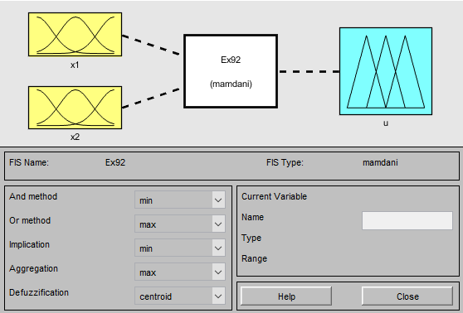
Figure 9.1: The model of the controller (a1)

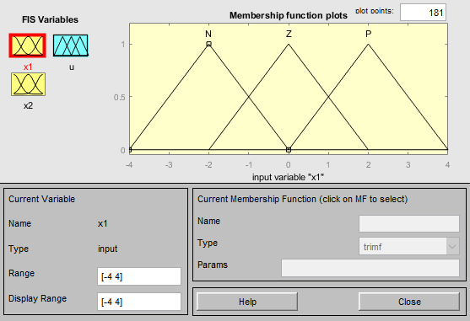
Figure 9.2: The input x1 triangular membership functions (a1)

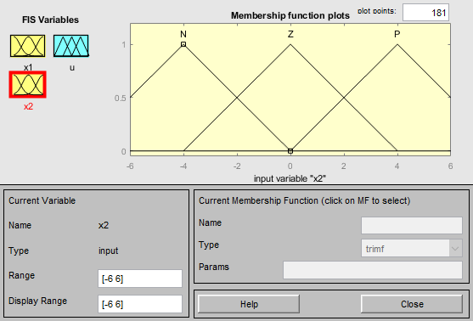
Figure 9.3: The input x2 triangular membership functions (a1)

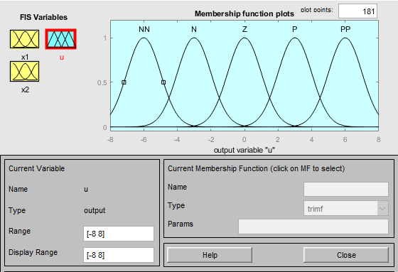
Figure 9.4: The output Gaussian membership functions (a1)

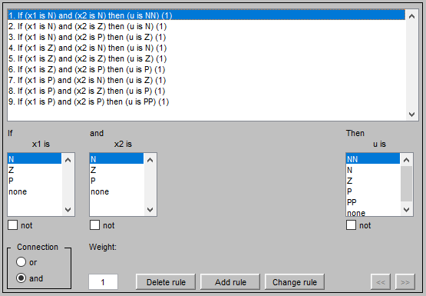
Figure 9.5: The rule base (a1)

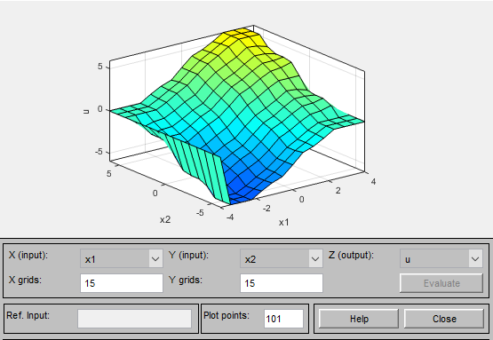
Figure 9.6: The characteristics of the controller (a1)

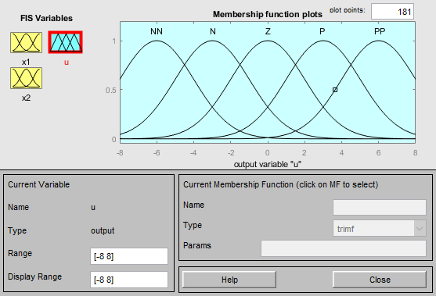
Figure 9.7: The output Gaussian membership functions (a2)

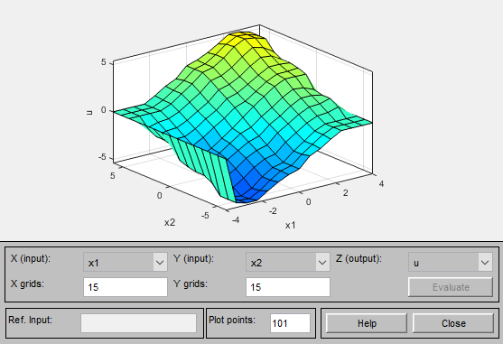
Figure 9.8: The characteristics of the controller (a2)

